Folder → ‘2021-07-19-Iris_active_results-steadystate_pupil’

N=25; [E, v, T_s] = [0-1 MPa, 0-.49, 0-1 Mpa]; a_sphincter = 1mm

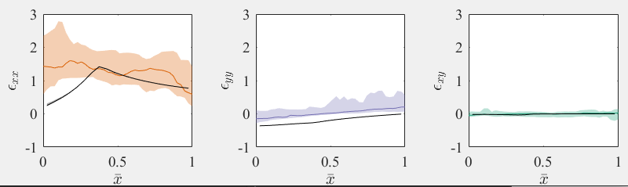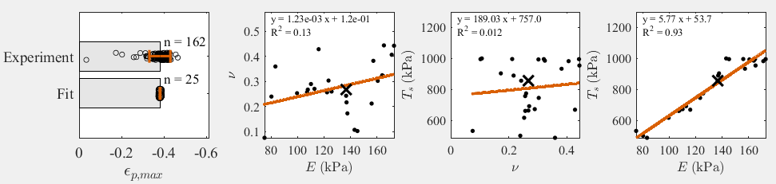5.

Folder → ‘2021-07-20-Iris_active_results-steadystata_sphincter = 1mme_pupil’

N=100; [E, v, T_s] = [0-1 MPa, 0-.49, 0-1 Mpa]; a_sphincter = 1mm

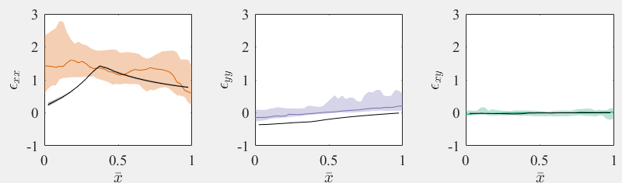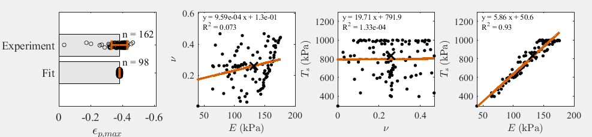

Folder → ‘2021-07-21-Iris_active_results-steadystate_pupil_lowRange’

N=100; [E, v, T_s] = [0-0.1 MPa, 0-.49, 0-0.1 MPa]; a_sphincter = 1mm

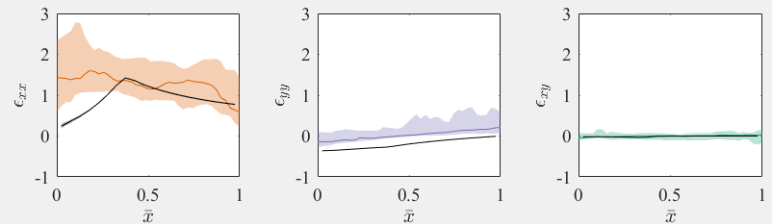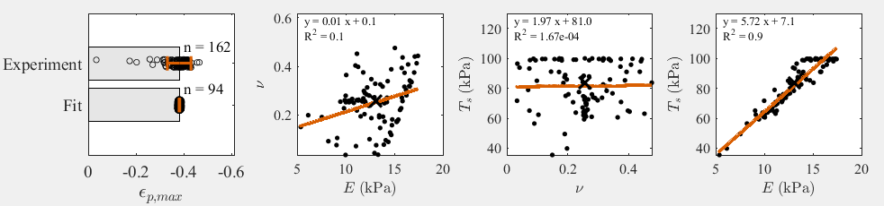

Folder → ‘2021-07-21-Iris_active_results-steadystate_pupil_a_s_Point4’

N=25; [E, v, T_s] = [0-1 MPa, 0-.49, 0-1 MPa]; a_sphincter = .4 mm

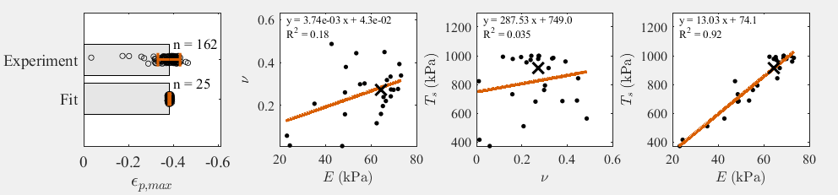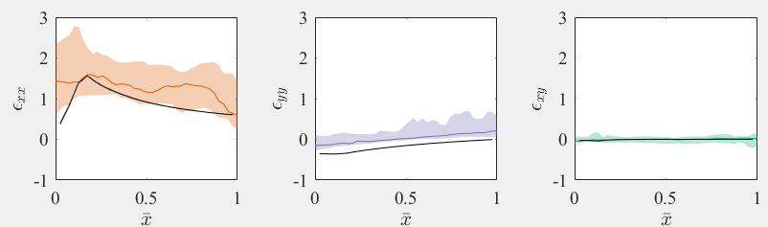

Folder → ‘2021-07-21-Iris_active_results-steadystate_pupil_a_s_Point7’

N=25; [E, v, T_s] = [0-1 MPa, 0-.49, 0-1 MPa]; a_sphincter = .7 mm

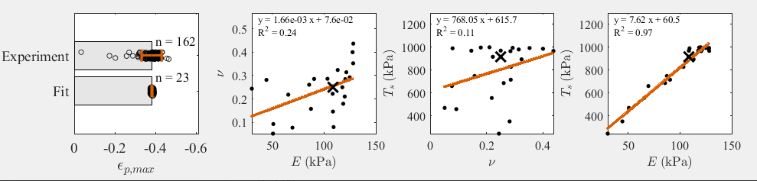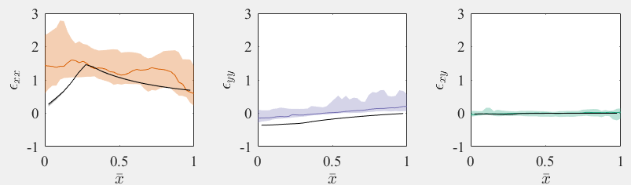

Folder → ‘2021-07-21-Iris_active_results-steadystate_pupil_a_s_1Point3’

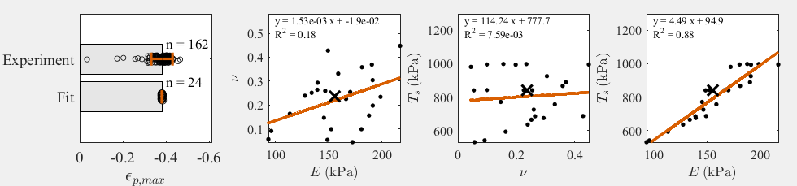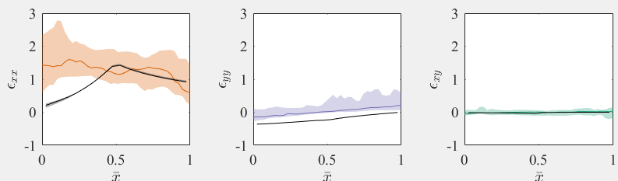N=25; [E, v, T_s] = [0-1 MPa, 0-.49, 0-1 MPa]; a_sphincter = 1.3 mm